Date | 18 June 2026
Project Name | Network Anomaly Detection
Maximum Marks | 4 Marks

Technical Architecture:

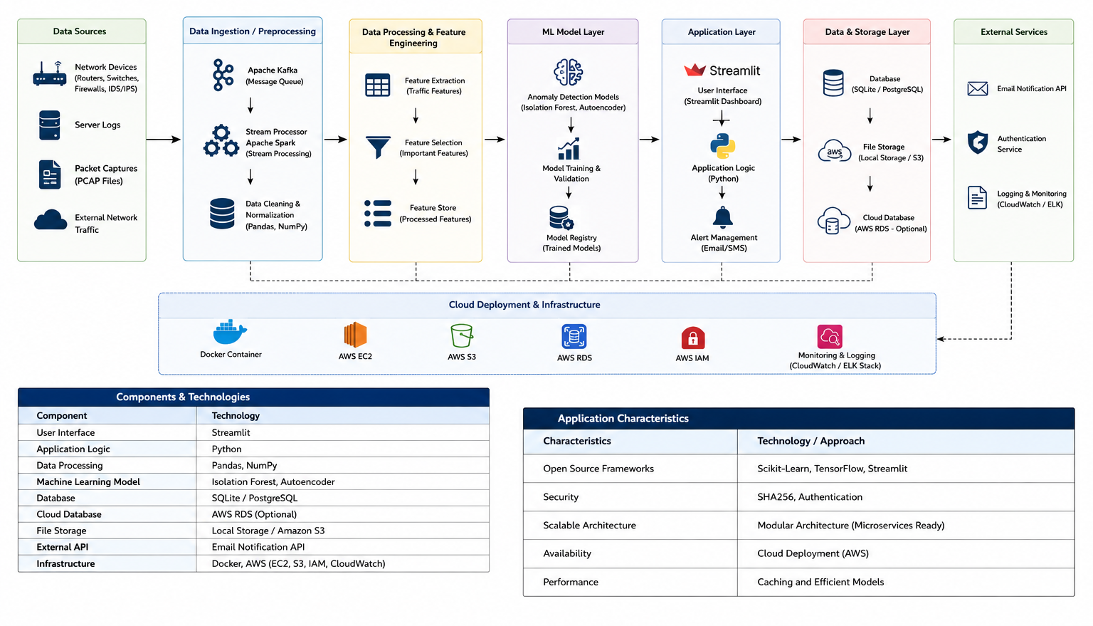

Table-1 : Components & Technologies:
Component | Technology
User Interface | Streamlit
Application Logic | Python
Data Processing | Pandas, NumPy
Machine Learning Model | Isolation Forest, Autoencoder
Database | SQLite / PostgreSQL
File Storage | Local Storage / Amazon S3
External API | Email Notification API
Infrastructure | Docker, AWS (EC2, S3, IAM, CloudWatch)

Table-2: Application Characteristics:

Characteristics | Technology / Approach
Open Source Frameworks | Scikit-Learn, TensorFlow, Streamlit
Security | SHA256, Authentication
Scalable Architecture | Modular Architecture (Microservices Ready)
Availability | Cloud Deployment (AWS)
Performance | Caching and Efficient Models

